VERY HIGH RESOLUTION REMOTE SENSING OF PORTULACARIA AFRA CANOPY COVER
By Dugal Harris
Thesis presented in partial fulfilment of the requirements for the degree of Master of Science/Arts at the Stellenbosch University.

Supervisor: Prof A van Niekerk
December 2014

DECLARATION

By submitting this report electronically, I declare that the entirety of the work contained therein is my own, original work, that I am the sole author thereof (save to the extent explicitly otherwise stated), that reproduction and publication thereof by Stellenbosch University will not infringe any third party rights and that I have not previously in its entirety or in part submitted it for obtaining any qualification.

Date:

Copyright © 2013 Stellenbosch University
All rights reserved

SUMMARY

Summary
KEY WORDS
Keywords

OPSOMMING

Opsomming

TREFWOORDE

ACKNOWLEDGEMENTS

I sincerely thank:
- My supervisor Prof Adriaan van Niekerk for his valuable guidance and support.
- Jan Vlok for initially suggesting the topic, providing expert botanical knowledge of my study area and for his generous assistance with ground truthing in the field.
- The Gamtoos Irrigation Board and Andrew Knipe for funding the research.
- Julie Verhulp, Raoul Duesemi and the rest of the staff at National Geospatial Information for their help with sourcing imagery of the study area.
- Adrian Roos of Intergraph SA for providing an evaluation license for the Intergraph ZIPPS calibration software.
- Bernhard Jacobs of Geospace for useful discussions on image calibration and for providing the camera calibration data.
- Theo Pauw and Garth Stephenson of the Centre for Geographical Analysis for providing software support and server access.

CONTENTS

DECLARATION ii
SUMMARY iii
OPSOMMING iv
ACKNOWLEDGEMENTS v
CONTENTS vi
TABLES vii
FIGURES viii
APPENDICES ix
ACRONYMS AND ABBREVIATIONS x
CHAPTER 1: TITLE OF CHAPTER 1 1
1.1 TITLE OF FIRST SECOND-TIER SUBHEADING 1
1.2 TITLE OF SECOND SECOND-TIER SUBHEADING 1
1.3 RESEARCH AIM AND OBJECTIVES 1
1.4 ANOTHER SUBHEADING 1
1.5 FINAL SUBHEADING OF CHAPTER 1 1
CHAPTER 2: TITLE FOR CHAPTER 2 2
2.1 FIRST FIRST-TIER SUBHEADING OF SECTION 2 2
2.1.1 Third-tier subheading 2
2.1.2 Another third-tier subheading 2
2.1.2.1 Fourth-tier subheading 2
2.1.2.2 Another fourth-tier subheading 3
2.1.3 Yet another third-tier subheading 3
REFERENCES 5
PERSONAL_COMMUNICATIONS 6
APPENDICES 7

TABLES

Table 2.1 An example of a table 4
Table 2.2 Another table with citation positioned below the table 4

FIGURES

Figure 2.1 Example of how a figure should be incorporated into the text 2
Figure 2.2 Another figure 3

APPENDICES

Appendix A: | Description
Appendix B: | Description

ACRONYMS AND ABBREVIATIONS

GIS | Geographical information systems
GPS | Global positioning systems
NGI | National Geospatial Information
SVM | Support Vector Machine
VHR | Very high resolution
DGPS | Differential GPS

Introduction
Portulacaria afra (Spekboom) is an evergreen succulent tree growing to 2.5m, with small fleshy leaves. It occurs in the Subtropical Thicket biome and is the dominant species in the arid and valley thicket habitat types (Vlok, Cowling & Wolf 2005). “The Subtropical Thicket habitat types are most easily recognized by the occurrence of woody trees, spinescent shrubs and a relative abundance of succulents. When occurring as solid stands the vegetation can form impenetrable dense thickets, but this is uncommon in the Little Karoo. In most of the area the Subtropical Thicket vegetation occurs as discrete bush-clumps, usually in a matrix of Succulent Karoo vegetation” (Vlok, Cowling & Wolf 2005: 41). While P. afra is tolerant of browsing by indigenous herbivores, it is highly susceptible to over browsing by goats (Marais, Cowling & Powell 2009; Sigwela et al. 2009; Mills et al. 2007; Mills et al. 2005). Poorly managed goat grazing transforms thicket into sparsely scattered thicket clumps, isolated trees and a covering of herbs (Mills et al. 2005). Figure 1.1 shows an example of degraded and intact P. afra thicket across a fence-line in the south-eastern Cape. Once thicket has been severely degraded, removing grazing pressure does not result in natural recovery (Mills et al. 2007; Vlok, Cowling & Wolf 2005).
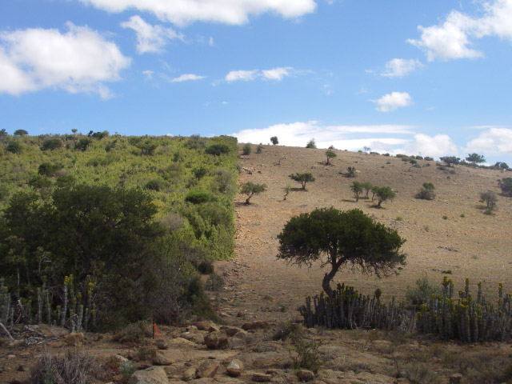
Figure 1.1 Intact and degraded subtropical thicket
Source: (Restoration Research Group 2012)

There is considerable interest in actively restoring degraded thicket habitat for several reasons. P. afra is unusually effective at storing carbon compared to other arid region vegetation. Measurements at a number of sites indicate that average rates of carbon storage lie between 1.2 and 4.2 t C ha⁻¹ yr⁻¹ (Van der Vyver et al. 2013; Mills & Cowling 2006). Further measurements in (Van der Vyver et al. 2013) support these figures. Comparison of degraded and intact sites has shown that restoration could sequester the order of 100 t C ha⁻¹ (Van der Vyver et al. 2013; Mills et al. 2005; Marais, Cowling & Powell 2009). These numbers compete with the carbon storage capacity of mesic forests (Mills et al. 2005). Carbon captured through restoration of P. afra can be traded as credits on the international carbon market. Using this as a source of funding for landscape-scale restoration is economically viable at current carbon prices (Mills et al. 2007; Marais, Cowling & Powell 2009). P. afra has the uncommon ability to switch between C3 and CAM photosynthetic systems depending on season (Guralnick & Ting 1986). This means it is productive year-round which likely contributes to its substantial sequestration abilities (Mills & Cowling 2010). P. afra propagates vegetatively and can thus be grown from cuttings (Stuart-Hill 1992) which means that costs of restoration can be reduced by avoiding nursery expenses (Mills & Cowling 2010). Subtropical Thicket provides an important source of food for many herbivores, including domesticated livestock (Thompson et al. 2009; Vlok, Cowling & Wolf 2005). Re-establishment of P. afra in degraded areas will help prevent soil erosion, reduce flood severity and improve water quality (Van Luijk et al. 2013; Mills & Cowling 2006). It is also attractive from an employment perspective; potentially creating thousands of jobs in impoverished areas, if implemented on a large scale. Increased biodiversity could help improve income from tourism and provide sustained access to wood, fruit, and medicines for local communities (Mills et al. 2007).

The dense canopy of P. afra facilitates an accumulation of soil organic matter which in turn significantly improves the water-holding capacity and fertility of the soil (Adie & Yeaton 2013; Mills & Cowling 2010; Lechmere-Oertel et al. 2008; Mills & Fey 2004). This, in addition to the provision of shade and increased rain run-off round the canopy perimeter, creates a favourable environment for other plants to grow (Adie & Yeaton 2013; Mills & Cowling 2010). It has been observed that over a period of 40 to 50 years, woody canopy and other species re-establish in P. afra restoration areas to a degree that restored thicket is compositionally comparable to intact thicket (Van der Vyver et al. 2013). An investigation into the feasibility of accelerating the restoration of woody canopy species through planting in P. afra restoration sites was conducted, but it was found that survival rates were poor and restoration costs prohibitive (Van der Vyver et al. 2012). It seems the most practical option for ecosystem restoration is to plant P. afra and allow other species to re-establish naturally through spontaneous recruitment (Mills et al. 2007).

Restoration research is being conducted as part of the Subtropical Thicket Restoration Project (STRP), which is an initiative of the Working for Woodlands Programme. “To evaluate methods of spekboom restoration, a partnership has been forged among scientists, government and an implementing agency. The South African government’s Working for Woodlands Programme … has engaged a group of scientists to assist in evaluating effective ways of using spekboom cuttings for restoration under different conditions …. The programme is being managed by an implementing agency, the Gamtoos Irrigation Board (GIB), rated as one of the best agencies used by Working for Water.” (Mills et al 2010: 9) P. afra restoration is also actively being conducted and monitored in the Baviaanskloof Nature Reserve, Addo Elephant National Park and the Fish River Reserve in the Eastern Cape (Mills et al. 2010). Approximately 1630 ha had been restored in these areas in 2012 (Van der Vyver et al. 2012).

Supporting spatial information is needed to aid the P. afra restoration process. Candidate restoration areas need to be identified. There are many factors to consider when selecting appropriate sites (Curran et al. 2012; Knight et al. 2011). A map of P. afra canopy cover is a key input to this decision-making process. Canopy cover can be used to estimate the expected carbon storage resulting from restoration. This provides an indication of the economic feasibility of restoration. Measures of intact canopy cover in a similar habitat to the restoration area are used to determine an appropriate planting density. Restoration progress can be monitored by updating the canopy cover map over time which would also assist in the carbon accounting required for trading credits on the international market (Mills et al. 2010). The canopy cover map would also be a useful tool for deepening the present understanding of the Subtropical Thicket biome.

A detailed vegetation map of the Little Karoo has been created at a 1:50000 scale (Vlok, Cowling & Wolf 2005). Using this map, a degradation mapping study was conducted in the Little Karoo (Thompson et al. 2009). It was successful at using MODIS data to estimate intact, moderate and severe degradation levels of P. afra thicket. Currently, there is an initiative to involve private land-owners in the restoration project in order to broaden its impact (Curran et al. 2012; Mills et al. 2010). Restoration planning at farm-level will require map scales of 1:10000 or better to provide sufficient spatial detail for working with expected stand sizes of the order of 50 hectares. To achieve sufficient accuracy for carbon storage estimations, it will be necessary to estimate canopy cover in finer detail than the three levels of degradation used in Thompson et al. (2009). There is thus a need to further the work of Thompson et al. (2009) to produce maps of both a higher spatial and canopy cover level resolution.

SIGNIFICANCE AND RATIONALE
Measures of canopy cover can be used to infer biomass for individual species (Ludwig, Reynolds & Whitson 1975). In the context of climate change, biomass is an important variable for monitoring ecosystem carbon dynamics. Carbon absorbed by vegetation and soils will play a significant role in efforts to reduce atmospheric CO₂ and in determining the development of future climate change (Eisfelder, Kuenzer & Dech 2012; Lu 2006). Canopy cover or biomass is also important from a perspective of understanding environmental processes and ecosystem services. Improved biomass is related to increased biodiversity (Lu 2006; Fabricius, Burger, and Hockey 2003), reduced erosion and improved soil fertility and water-holding ability (Eisfelder, Kuenzer & Dech 2012; Mills & Cowling 2010; Lechmere-Oertel et al. 2008; Mills & Fey 2004).

Under the Kyoto Protocol, ratified countries are legally bound to reduce CO₂ emissions to capped levels. If these levels are exceeded, countries can make up the deficit by buying carbon credits from another country that was able to reduce its emissions below its target level (Mills et al. 2010). The Clean Development Mechanism (CDM) is a means by which developing countries can run sequestration projects and trade carbon credits on the international market. There are also the Voluntary Carbon Standard (VCS), Community, Climate and Biodiversity Standard (CCBS) which work on a similar basis to the CDM, but don’t require authorisation by the host country. Under these schemes there are legal provisions that require rigorous accounting of stored carbon. These measurements are time consuming and costly when performed manually (Eisfelder, Kuenzer & Dech 2012; Lu 2006). Canopy cover measurements are currently being done by visual inspection in the field. There is a need for greater accuracy and repeatability than is possible with this technique. A P. afra canopy cover map would serve as a first step towards achieving the required carbon storage measurements via remote sensing on a large scale.

The benefits of P. afra restoration are manifold and include benefits for local communities. The STRP has placed a strong emphasis on stakeholder engagement and community development (Marais, Cowling & Powell 2009). Restored areas will provide increased capacity for supporting judiciously managed livestock and employment for thousands of workers if restoration is implemented on a large scale (Mills et al. 2010). Employment is particularly relevant for the Eastern Cape where unemployment rates are amongst the highest in South Africa at roughly 27% (Statistics South Africa 2011).

This research presents a number of challenges from a technical remote sensing perspective. There is VHR (0.5m/pixel) multi-spectral data with national coverage available from National Geo-spatial information (NGI) (National Geo-spatial Information 2012). This imagery represents a rich source of information, but to date it has only been used for topographical mapping and photo-interpretation. To the best of the author’s knowledge, this will be the first study to exploit this imagery for automated vegetation monitoring. Use of VHR imagery for estimation of environmental variables is fairly uncommon, especially over large areas such as the Little Karoo (Eisfelder, Kuenzer & Dech 2012; Lu 2006). Figure 1.2 shows an example colour infra-red (CIR) image of P. afra thicket from NGI.

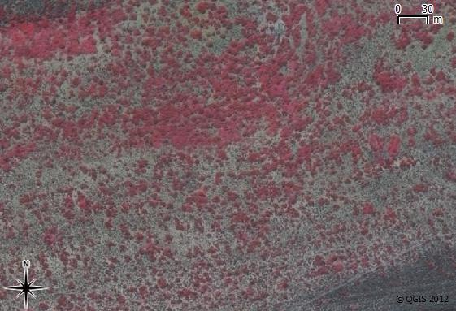
Figure 1.2 CIR Image of P. afra Thicket

Another aspect of this research that has been relatively unexplored in the literature is measuring some aspect of degradation, like canopy cover, in an arid environment. Research on measurement of indicators in forest ecosystems is fairly well established (Lu 2006; Wulder et al. 2004; Lévesque & King 2003). Arid regions present some remote sensing challenges not typically encountered in forests. These include the naturally sparse vegetation cover and mixing of soil and vegetation spectra (Eisfelder, Kuenzer & Dech 2012; Thompson et al. 2009). Arid regions cover roughly one third of the terrestrial land surface (Food and Agriculture Organization (FAO) 1989) and are particularly sensitive to degradation (Mills et al. 2005; Stuart-Hill 1992). Remote sensing techniques applicable to arid environments are therefore of importance.

Dealing with sources of unwanted variation is a recurring difficulty reported in the remote sensing literature (Eisfelder, Kuenzer & Dech 2012; Baraldi et al. 2010; Lu 2006). Achieving an accurate canopy cover mapping over a large spatial scale and using a mosaic of images acquired at different times requires an algorithm that is robust to many of the variations commonly encountered. These include varying topography and P. afra habitats, [phenological changes] and shadow variations. Dealing with these challenges has comprised a significant portion of the research effort.

PROBLEM STATEMENT
Habitats supporting P. afra have been degraded by overgrazing over much of their range. There is significant interest and a growing body of research in P. afra restoration. Restoration projects will generate employment, restore ecosystem services and produce carbon credits that can be traded to offset restoration costs. There is a need for spatial information, in the form of P. afra canopy cover maps, to support restoration projects in the identification of suitable areas to plant and in the monitoring of restoration progress at repeated intervals. Restoration is planned for large areas of the Little Karoo and Eastern Cape. Map scales of at least 1:10000 are required to provide sufficient accuracy for farm-level restoration planning.

RESEARCH AIM AND OBJECTIVES
The research aim is to develop an automated or semi-automated image analysis technique to accurately estimate P. afra canopy cover in pristine and transformed areas from very high resolution (VHR) remotely sensed imagery, covering large areas.
To achieve the research aim, the following objectives have been set:
- Perform a literature survey covering P. afra restoration, vegetation and canopy cover mapping in arid environments and vegetation and canopy cover mapping using VHR imagery.
- Perform a field study to establish a number of reference sites, across a variety of habitats. Determine the ground truth canopy cover for each site.
- Source and calibrate and rectify aerial imagery from National Geo-spatial Information (NGI).
- Develop a classifier that distinguishes P. afra from surrounding vegetation.
- Apply the classifier to imagery of the study area. Interpret and validate the results.

STUDY AREA (possibly incl in later chapter for paper)
The Little Karoo as defined in Vlok, Cowling & Wolf (2005), was selected as the area of interest. The Subtropical Thicket biome makes up 35.3% of the Little Karoo which has a total area of 2 343 900 ha (Vlok, Cowling & Wolf 2005). It was found that 89.3% of the P. afra thicket was degraded to some extent in a study area comprising roughly half the area of the Little Karoo (Thompson et al. 2009). The Little Karoo was chosen as a study area because it contains a significant portion of P. afra suited and degraded habitat and has been targeted for restoration. It is also beneficial that a number of relevant studies have been performed in the area (Thompson et al. 2009; Forsyth, Vlok & Reyers 2008; Vlok, Cowling & Wolf 2005). While the maps produced by these studies are not at a 1:10000 scale, they have nevertheless proved useful to this research as a source of ancillary data. [ and a means of conducting coarse validation tests].

To expedite computing times and reduce storage space required for the VHR imagery, a reduced portion of the Little Karoo was chosen as the study area, as shown in Figure 1.3. This reduced area was chosen to be as representative of the variation in the Little Karoo as possible. It consists of four different aerial survey jobs flown at different times and thus still poses a challenging calibration problem. It also includes examples of all the different biomes and nine of the ten habitat types supporting P. afra as defined by Vlok, Cowling & Wolf (2005).

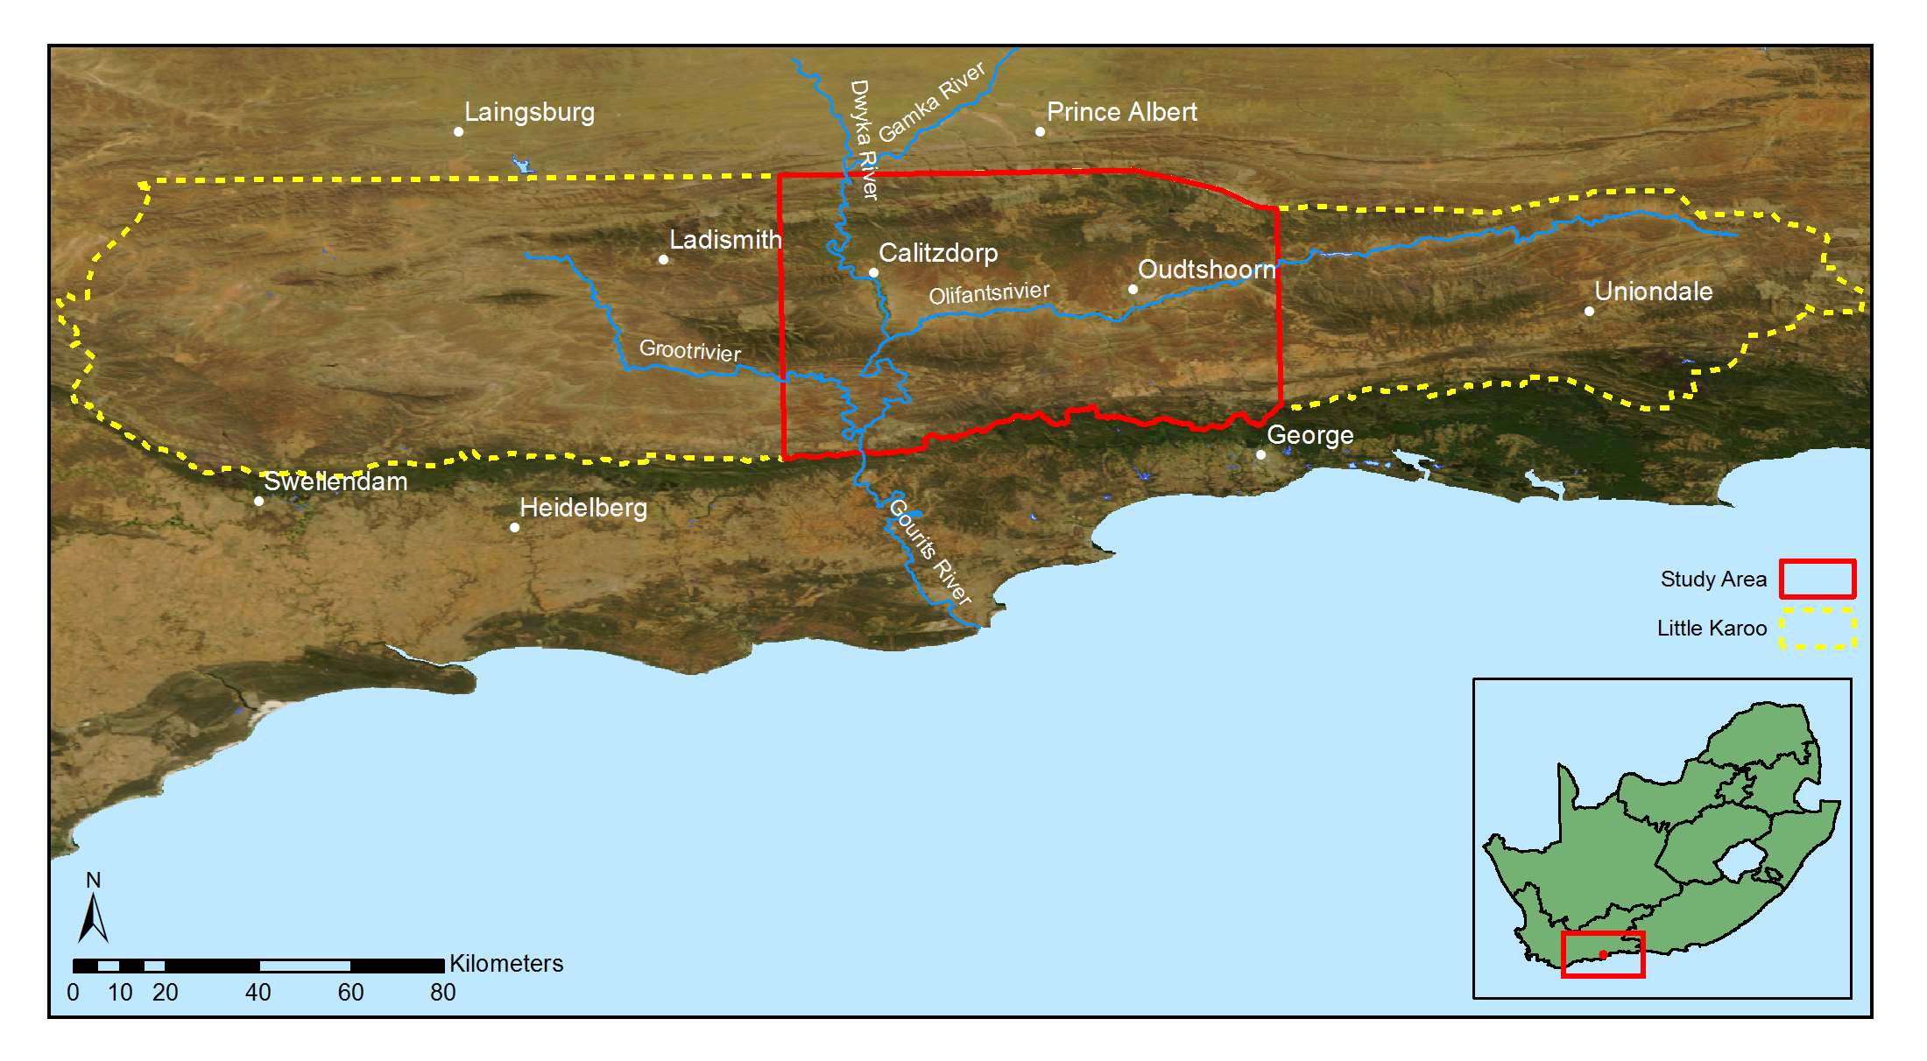
Figure 1.3 Little Karoo study area

METHODOLOGY
Canopy cover measurements are currently being conducted manually by visual inspection in the field. While this is a common approach for measuring environmental indicators, it is time consuming and only practical for small areas (Eisfelder, Kuenzer & Dech 2012; Lu 2006). A visual inspection is also prone to repeatability issues due to the subjectivity of the inspector. P. afra restoration is envisioned for large areas of the Eastern Cape and Little Karoo and will require monitoring of plant growth over time. Repeatability and accuracy constraints on carbon measurements are stringent in order to achieve the necessary accreditation for carbon trading in schemes like the CDM. This research followed a quantitative remote sensing methodology. This approach is common for biomass estimation (Eisfelder, Kuenzer & Dech 2012; Lu 2006) and is chosen as it will facilitate accurate canopy cover estimation of large areas and at repeated intervals. Using the categorisation of Mouton (2001), this research can be classed as a methodological study.

An empirical approach was used for developing the canopy cover estimation. Various secondary measurements or features were extracted from the remotely sensed data and used to build a model of P. afra canopy cover. Similar approaches for measuring degradation or biomass in an arid environment were successful in Thompson et al. (2009) and Ludwig, Reynolds & Whitson (1975). The accuracy of the model was tested against unseen data as a check against overfitting (Jain, Duin & Mao 2000).

This work is intended to be applied research. Emphasis was placed on producing a map that is both useful and usable (Pierce et al. 2005). [This required interaction and communication with stake-holders (Knight et al. 2011), specifically environmental practitioners currently involved in performing canopy cover assessments, the STRP and the GIB, who are the restoration implementing agents (Mills et al. 2010). ]

There is a tendency for environmental remote sensing to be conducted in an isolated way that does not allocate adequate importance to understanding complex human and ecological processes affecting the data being analysed (Hein et al. 2011; Turner 2003). This naïve approach can lead to models that do not generalise well over varying spatial and temporal conditions. Recognition of the value of multi-disciplinary teams incorporating expert knowledge of local conditions and field experience is given in Knight et al. (2011) and Thompson et al. (2009). This research was undertaken in collaboration with a botanist, Jan Vlok, who has a wealth of experience in the Little Karoo (Thompson et al. 2009; Forsyth, Vlok & Reyers 2008; Vlok, Cowling & Wolf 2005) and with P. afra in particular. His insight into local habitat variations and involvement in restoration work was invaluable to the study.

Remember to link the end of this chapter to the next chapter.

Summarise chapters
Also remember there are relevant methodology sections from the proposal missing from here

TITLE FOR CHAPTER 2
Provide an introduction to the section here.

FIRST FIRST-TIER SUBHEADING OF SECTION 2
Add content here. Figure 2.4 is an example of how to include a picture in your report.
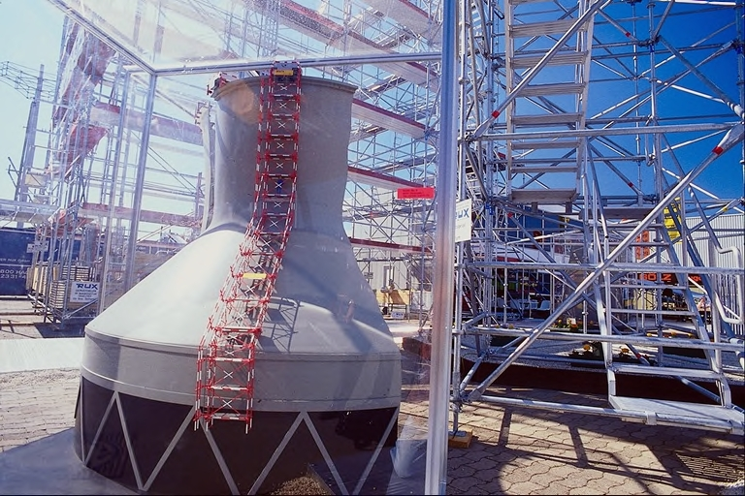
Adapted from Whoever (2000)

Figure 2.4 Example of how a figure should be incorporated into the text

Third-tier subheading
First paragraph.
Second paragraph.
Add paragraphs as needed.

Another third-tier subheading
Add content here.

Fourth-tier subheading
Add content.

Another fourth-tier subheading
Add content.

Yet another third-tier subheading
Here is an example of how an equation should be incorporated in the text:
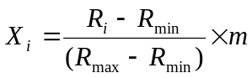 |  |  | Equation 2-1
where | R_{i} | is the raw score;
 | R_{min} | represents the minimum score;
 | R_{max} | is the maximum score; and
 | m | is an arbitrary multiplier representing the upper standardized range value.

Another figure below (Figure 2.5).

Figure 2.5 Another figure
Table 2.1 is an example of how to include a table in your report. Notice the citation next to the table. All tables (and figures) must be referenced in the text. This table is referenced using MS Word’s Cross-reference tool (i.e. it creates a field). By using this tool, your references in the text will change dynamically even if your table number changes. To update fields, press Ctrl-A (to select all text) and then press F9.
Table 2.1 An example of a table
ID | Description
1 | Equal importance
3 | Moderate importance
5 | Strong or essential importance
7 | Very strong or demonstrated importance
9 | Extreme importance
2, 4, 6, 8 | Intermediate values
Reciprocals | Inverse comparison  Source Saaty & Vargas (1991)

If there is no space next to a table, then add the reference below the table. This is another cross-reference to Table 2.2.
Table 2.2 Another table with citation positioned below the table
 | Effective soil depth | Soil acidity | Slope gradient | Slope aspect | Priorities (%)
Effective soil depth | 1 | 2 | 3 | 3 | 44
Soil acidity | 1/2 | 1 | 3 | 3 | 31
Slope gradient | 1/3 | 1/3 | 1 | 1/2 | 10
Slope aspect | 1/3 | 1/3 | 2 | 1 | 15
Saaty & Vargas (1991)
See guidelines for more instructions on referencing tables and figures.
Never end your section with a table or figure.

REFERENCES

Add your reference list here.
You can use Endnote or Refworks to create a reference list automatically. Here are some examples:
Abran A, Moore JW, Bourque P & Dupuis R (eds) 2004. The software engineering body of knowledge guide. Los Alamitos: IEEE Computer Society Professional Practices Committee.
Adediran AO, Parcharidisb I, Poscolieric M & Pavlopoulosd K 2004. Computer-assisted discrimination of morphological units on north-central Crete (Greece) by applying multivariate statistics to local relief gradients. Geomorphology 58: 357-370.
Agrell PJ, Stam A & Fischer GW 2004. Interactive multiobjective agro-ecological land use planning: The Bungoma region in Kenya. European Journal of Operational Research 158: 194-217.

Adie, H & Yeaton, RI 2013. Regeneration dynamics in arid subtropical thicket, South Africa. South African Journal of Botany 88: 80–85.
Baraldi, A, Durieux, L, Simonetti, D, Conchedda, G, Holecz, F & Blonda, P 2010. Automatic spectral-rule-based preliminary classification of radiometrically calibrated SPOT-4/-5/IRS, AVHRR/MSG, AATSR, IKONOS/QuickBird/OrbView/GeoEye, and DMC/SPOT-1/-2 imagery—Part I: System design and implementation. IEEE Transactions on Geoscience and Remote Sensing 48 (3): 1299–1325.
Curran, P, Smedley, D, Thompson, P & Knight, AT 2012. Mapping restoration opportunity for collaborating with land managers in a carbon credit-funded restoration program in the Makana municipality, Eastern Cape, South Africa. Restoration Ecology 20 (1): 56–64.
Eisfelder, C, Kuenzer, C & Dech, S 2012. Derivation of biomass information for semi-arid areas using remote-sensing data. International Journal of Remote Sensing 33 (9): 2937–2984.
Fabricius, C, Burger, M & Hockey, PAR 2003. Comparing biodiversity between protected areas and adjacent rangeland in xeric succulent thicket, South Africa: arthropods and reptiles. Journal of Applied Ecology 40 (2): 392–403.
Food and Agriculture Organization (FAO) 1989. Arid zone forestry: a guide for field technicians. [online]. Available from: http://www.fao.org/docrep/T0122E/t0122e03.htm [Accessed May 22, 2012].
Forsyth, G, Vlok, J & Reyers, B 2008. Retention and restoration of the biodiversity of the Little Karoo. CSIR Report No CSIR/NRE/ECO/ER/2008/0118/C. Critical Ecosystem Partnership Fund, CSIR.
Guralnick, LJ & Ting, IP 1986. Seasonal response to drought and rewatering in Portulacaria afra (L.) Jacq. Oecologia 70: 85–91.
Hein, L, de Ridder, N, Hiernaux, P, Leemans, R, de Wit, A & Schaepman, M 2011. Desertification in the Sahel: Towards better accounting for ecosystem dynamics in the interpretation of remote sensing images. Journal of Arid Environments 75 (11): 1164–1172.
Jain, AK, Duin, RPW & Mao, J 2000. Statistical pattern recognition : A review. IEEE Transactions on Pattern Analysis and Machine Intelligence 22 (1): 4–37.
Knight, AT, Cowling, RM, Boshoff, AF, Wilson, SL & Pierce, S 2011. Walking in STEP: Lessons for linking spatial prioritisations to implementation strategies. Biological Conservation 144 (1): 202–211.
Lechmere-Oertel, RG, Kerley, G, Mills, AJ & Cowling, RM 2008. Litter dynamics across browsing-induced fenceline contrasts in succulent thicket, South Africa. South African Journal of Botany 74 (4): 651–659.
Lévesque, J & King, DJ 2003. Spatial analysis of radiometric fractions from high-resolution multispectral imagery for modelling individual tree crown and forest canopy structure and health. Remote Sensing of Environment 84 (4): 589–602.
Lu, D 2006. The potential and challenge of remote sensing based biomass estimation. International Journal of Remote Sensing 27 (7): 1297–1328.
Ludwig, JA, Reynolds, JF & Whitson, PD 1975. Size-biomass relationships of several Chihuahuan desert shrubs. American Midland Naturalist 94 (2): 451–461.
Van Luijk, G, Cowling, RM, Riksen, MJPM & Glenday, J 2013. Hydrological implications of desertification: Degradation of South African semi-arid subtropical thicket. Journal of Arid Environments 91: 14–21.
Marais, C, Cowling, RM & Powell, M 2009. Establishing the platform for a carbon sequestration market in South Africa: The Working for Woodlands Subtropical Thicket Restoration Programme. In XIII World Forestry Congress, 1–13. Buenos Aires, Argentina.
Mills, AJ, Blignaut, J, Cowling, RM, Knipe, A, Marais, C, Marais, S, Pierce, S, Powell, M, Sigwela, A & Skowno, A 2010. Investing in sustainability. Restoring degraded thicket, creating jobs, capturing carbon and earning green credit. Published by Climate Action Partnership, Cape Town, and Wilderness Foundation, Port Elizabeth.
Mills, AJ & Cowling, RM 2010. Below-ground carbon stocks in intact and transformed subtropical thicket landscapes in semi-arid South Africa. Journal of Arid Environments 74 (1): 93–100.
Mills, AJ & Cowling, RM 2006. Rate of carbon sequestration at two thicket restoration sites in the Eastern Cape, South Africa. Restoration Ecology 14 (1): 38–49.
Mills, AJ, Cowling, RM, Fey, M, Kerley, G, Donaldson, J, Sigwela, A, Skowno, A & Rundel, P 2005. Effects of goat pastoralism on ecosystem carbon storage in semiarid thicket , Eastern Cape , South Africa. Austral Ecology 30: 797–804.
Mills, AJ & Fey, M 2004. Transformation of thicket to savanna reduces soil quality in the Eastern Cape, South Africa. Plant and Soil 265 (1-2): 153–163.
Mills, AJ, Turpie, JK, Cowling, RM, Marais, C, Kerley, G, Richard, G, Sigwela, A & Powell, M 2007. Assessing costs, benefits, and feasibility of restoring natural capital in Subtropical Thicket in South Africa. In J. Aronson, S. Milton, & J. Blignaut (eds.) Restoring Natural Capital: Science, Business and Practice (The Science and Practice of Ecological Restoration Series), 179–187. Island Press.
Mouton, J 2001. How to succeed in your master’s and doctoral studies : a South African guide and resource book. Pretoria: Van Schaik Publishers.
National Geo-spatial Information 2012. National Aerial Photography and Imagery Programme [online]. Department of Rural Development and Land Reform (DRDLR). Available from: http://www.ngi.gov.za/index.php/Image-tabs-home/national-aerial-photography-and-imagery-programme.html [Accessed May 22, 2012].
Pierce, S, Cowling, RM, Knight, AT, Lombard, AT, Rouget, M & Wolf, T 2005. Systematic conservation planning products for land-use planning: Interpretation for implementation. Biological Conservation 125 (4): 441–458.
Restoration Research Group 2012. Intact and degraded Spekboomveld [online]. Available from: http://www.r3g.co.za/spekboom.htm [Accessed May 15, 2012].
Sigwela, A, Kerley, G, Mills, AJ & Cowling, RM 2009. The impact of browsing-induced degradation on the reproduction of subtropical thicket canopy shrubs and trees. South African Journal of Botany 75 (2): 262–267.
Statistics South Africa 2011. Quarterly Labour Force Survey Quarter 1, 2011. P0211 .Pretoria: Statistics South Africa.
Stuart-Hill, G 1992. Effects of elephants and goats on the Kaffrarian succulent thicket of the eastern Cape, South Africa. Journal of Applied Ecology 29 (3): 699–710.
Thompson, M, Vlok, J, Rouget, M, Hoffman, MT & Cowling, RM 2009. Mapping grazing-induced degradation in a semi-arid environment: A rapid and cost effective approach for assessment and monitoring. Environmental Management 43: 585–596.
Turner, MD 2003. Methodological reflections on the use of remote sensing and geographic information science in human ecological research. Human Ecology 31 (2): 255–279.
Vlok, J, Cowling, RM & Wolf, T 2005. A vegetation map for the Little Karoo. Unpublished maps and report for a SKEP project supported by CEPF grant no 1064410304.
Van der Vyver, ML, Cowling, RM, Campbell, EE & Difford, M 2012. Active restoration of woody canopy dominants in degraded South African semi-arid thicket is neither ecologically nor economically feasible T. O’Connor, ed. Applied Vegetation Science 15 (1): 26–34.
Van der Vyver, ML, Cowling, RM, Mills, AJ & Difford, M 2013. Spontaneous Return of Biodiversity in Restored Subtropical Thicket: Portulacaria afra as an Ecosystem Engineer. Restoration Ecology 21 (6): 736–744.
Wulder, MA, Hall, RJ, Coops, NC, Steven, E & Franklin, SE 2004. High spatial resolution remotely sensed data for ecosystem characterization. BioScience 54 (6): 511–521.

PERSONAL COMMUNICATIONS

List your personal communications here.
See the departmental guidelines for instructions.

APPENDICES

Appendix A | Title of first appendix | 8
Appendix B | Title of second appendix | 9

APPENDIX A

Title of fist appendix

Appendix content
APPENDIX B

Title of second appendix

Content

Note: These references were automatically inserted here (at the end of the document) by EndNote and must be manually copied to the reference list. Alternatively, one can put the appendixes in a separate document so that the reference list is at the very end of the document. This will automatically update your reference list as you work on the document.

